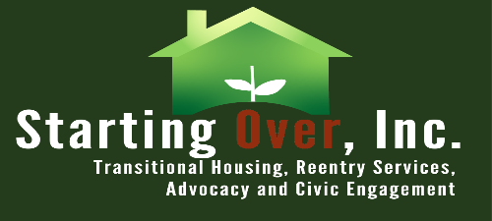

Starting Over, Inc.
6355 Riverside Ave., Riverside CA 92506
www.startingoverinc.org

JOB TITLE
Policy Associate
$28.00-$30.00

Job Summary:
The Policy Associate plays a critical role in supporting the policy and advocacy efforts of Starting Over Inc.. The Policy Associate works closely with the policy team, senior staff, and external stakeholders to develop, analyze, and advocate for policies that align with our mission and goals. The Policy Associate conducts research, monitors policy developments, engages in strategic communications, and helps shape the organization's policy agenda.

General Duties:
Conduct research on policy issues related to Starting Over’s mission and goals. Analyze legislation, regulations, and policy proposals to assess their impact. Identify trends, emerging issues, and best practices in the policy field. Prepare reports, briefs, and summaries of policy research and analysis. Assist in the development and formulation of policy positions and recommendations. Collaborate with the policy team to create advocacy strategies and action plans. Engage in legislative and regulatory advocacy efforts. Build relationships and collaborate with external stakeholders, such as government agencies, partner organizations, and community groups. Represent our organization at meetings, conferences, and policy-related events. Prepare policy briefs, fact sheets, and other materials for internal and external audiences. Assist in organizing policy forums, workshops, and events. Contribute to the organization's website, blog, and social media platforms. Respond to inquiries from the media, policymakers, and the public on policy-related matters. Monitor legislative and regulatory activities at the local, state, and federal levels. Track policy developments, proposals, and implementation progress. Evaluate the effectiveness of policy initiatives and recommend adjustments as needed. Maintain accurate records of policy activities, including data collection and reporting.

Job Qualifications:
Knowledge of policy issues related to the non-profit organization's mission. Familiarity with legislative and regulatory processes. Ability to work independently and collaboratively in a fast-paced environment. Strong organizational and project management abilities. Experience with data analysis and visualization tools is a plus. Demonstrated commitment to social justice and the non-profit sector. Bachelor's degree in public policy, political science, international relations, or a related field (master’s degree preferred).

Skills:
Strong research, analytical, and critical thinking skills.
Effective verbal and written communication skills, public speaking skills.
Proficiency with Microsoft Office, Gmail suite, data entry and other relevant software.
Strong interpersonal and active listening skills.
Strong organizational and project management abilities

